**24-677 Modern Control Theory  
Project 2**

**Exercise 1:**

1. **Determine Controllability and Observability**
   1. **Controllable and Observable**

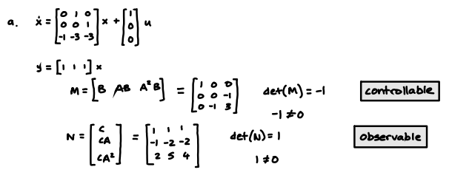

* 1. **Controllable and Observable**

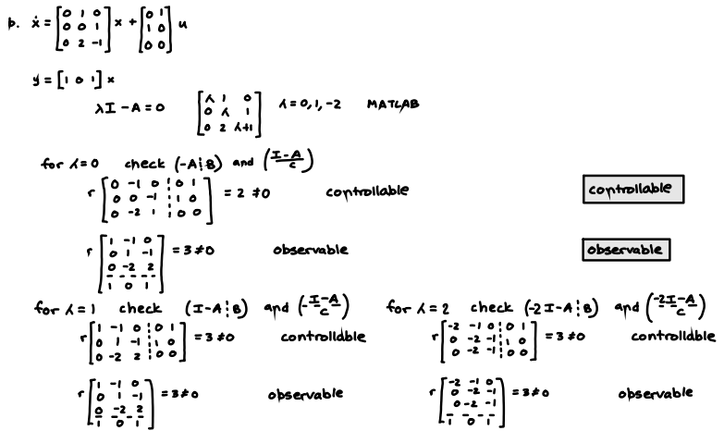

* 1. **Controllable and Not Observable**

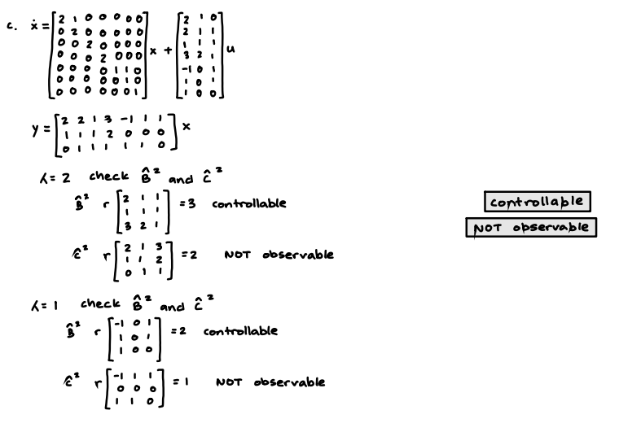

1. **State Space Realizations**

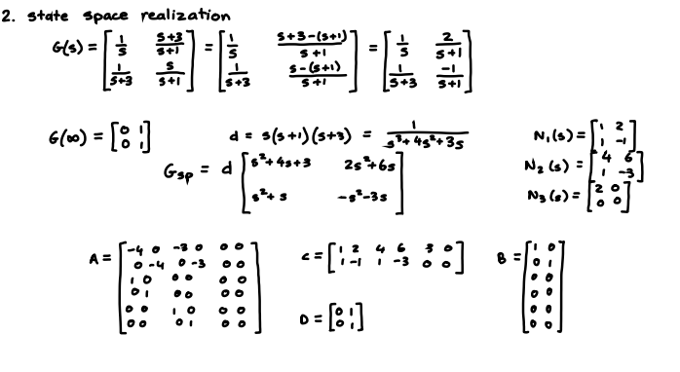

1. **State Feedback Control Matrix K**

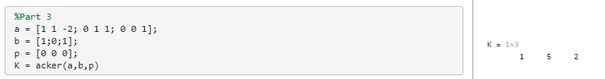

1. **Observer Matrix L**

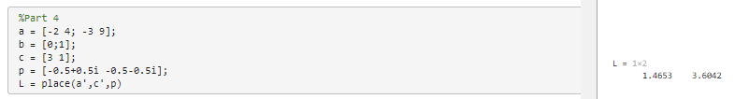

**Exercise 2:**

1. **Longitudinal Velocities Controllability**

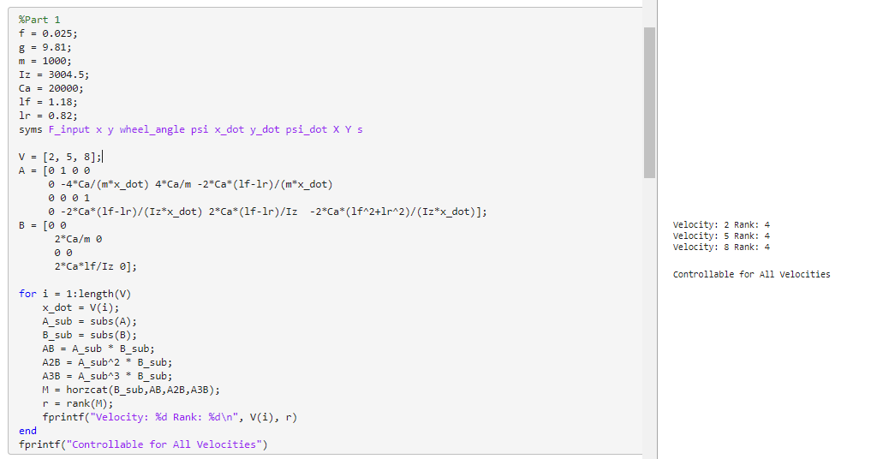

1. **Plots Longitudinal Velocities**
   1. 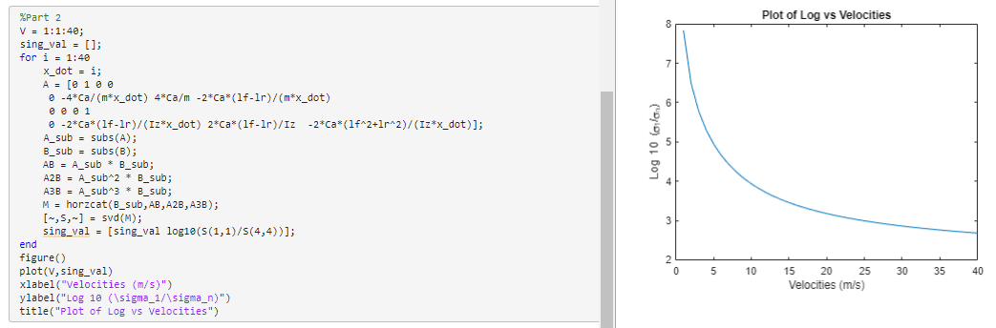
   2. 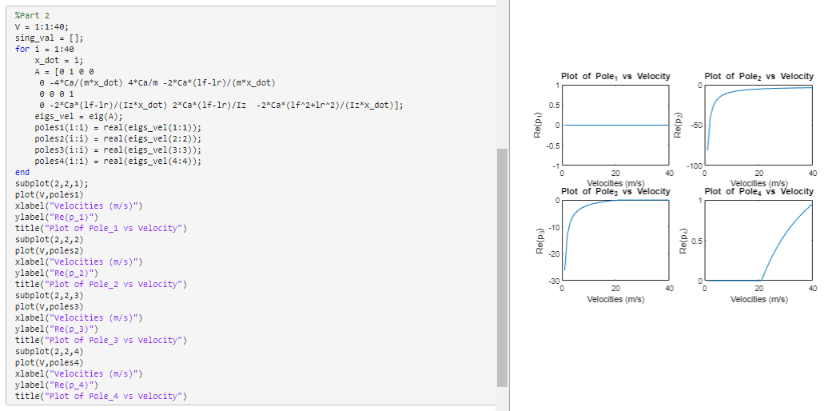
   3. The conclusion that can be made about the overall controllability and stability of the system based on these two plots is that the system seems to be more controllable for the higher longitudinal velocities in regards to the lateral direction. This may be attested due to the SVD values or ratios where the smaller the value, the less the system is flawed. So, in the case of the tractor, it will be easier to control at high speeds in the lateral direction. The poles graph shows that the system will be more unstable as the velocity increases. Along with that, we see the system is unstable at velocity near 20.
2. **Velocity Observabilities**
   1. 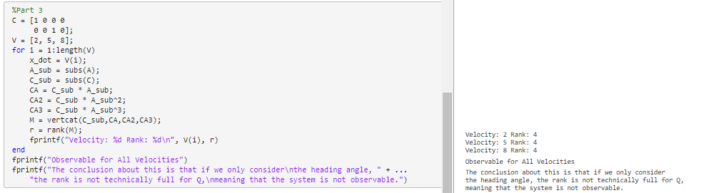
3. **Pole Placement**
   1. **poles = np.array([-5, -4, -0.5, 0])**
      1. Tractor is too fast and completely misses the road, picked random numbers that were relatively “small”
   2. **poles = np.array([-15,-25,-2,0])**
      1. Worked perfect with new poles, picked farther away from axis for more accuracy and a slightly slower response
   3. **poles = np.array([-15,-25,-1,0])**
      1. Wanted to see if the third pole had a drastic impact, changed value slightly but system performed better
4. **Reconstruct the Error Derivative States**
   1. We can find the error derivatives by taking the difference between the current error and the previous step's error and taking the entire thing and dividing it by the time we take during each step.

**Exercise 3:**

